Software Requirements Specification

for

Digital Product E-commerce

Version 1.0 approved

Prepared by CSE327 Group: 9

15 November 2021

**Table of Contents**

1. Introduction 1

1.1 Purpose 1

1.2 Intended Audience and Reading Suggestions 1

1.3 Product Scope and Goals 1

1.4 Risk 1

2. Overall Description 2

2.1 Product Perspective 2

2.2 User Classes and Characteristics 2

2.3 Operating Environment 2

2.4 Constraints 3

2.5 Assumptions and Dependencies 3

3. External Interface Requirements 3

3.1 User Interfaces 3

3.2 Hardware Interfaces 4

3.3 Software Interfaces 4

4. System Features 4

4.1 User Case Diagram 4

5. Other Nonfunctional Requirements 5

Revision History

|  |  |  |  |
| --- | --- | --- | --- |
| **Name** | **Date** | **Reason For Changes** | **Version** |
|  |  |  |  |
|  |  |  |  |

# Introduction

## Purpose

The purpose of this SRS document is to provide a detailed overview of our software product, its parameter and goals. This document describes the project’s target audience and its user interface, and software requirements. Here Visitors can see the publicly available features such as browse products, view details of products. We will build this application using MySQL, PHP, Laravel, HTML, and CSS.

## Intended Audience and Reading Suggestions

This document is intended for developers, Customers, Project manager, marketing staff, users, testers, and documentation writers. This Software Requirements Specification are for:

* Developers
* End users

Developers: Developers who can review the project’s capabilities and more easily understand where their efforts should be targeted to improve or add more features to it (design and code the application – it sets the guidelines for future development). They can further update this project for betterment.

End-users: End-users of this application who wish to read about what this project can do. This the user guide for them to use this application properly

## Product Scope and Goals

* This software system will be a Web Publishing System
* Users should be able to register through their already existing accounts.
* They should be able to share snaps/videos/snaps.
* People should be able to like and comment on any post.
* One person can follow another person who shares common interests and likings which would enable them to find mates apart from their usual friend circle.
* Each user can have his/her profile picture, status.
* User can easily buy their pin code through online payment system like bKash, rocket.
* People can post mysteries and other people can solve the mysteries.
* Users will get points for the popularity of their posts/the number of mysteries they solve.

## Risk

* Online Security Risks
* Client disputes and refunds
* Violation of Intellectual property
* Low SEO ranking
* Credit cards scams
* Poor customer service
* Weak authentication methods
* Website Downtime Risk
* **Website Traffic Interruptions**

# Overall Description

## Product Perspective

In this modern era, e-commerce sites are providing newer, better, and quicker ways to buy and sell the products that we need. But we’ve chosen a unique idea to purchase educational and digital platform accounts at lower prices. In detail, it helps students and viewers provide quality content like courses, educational technology accounts, live streaming, software, etc. Our team tried our best to make it user-friendly so that everyone could purchase their item according to their needs.

## User Classes and Characteristics

Most of our targeted purchasers are students. Nowadays, online courses have become popular among all students. These courses provide the necessary instruments to gain knowledge about a specific topic. We have also included a live streaming platform for most of the audience to know about news, movies, music, and all. They could purchase their favorite streaming site’s account at a lower price.

As we said before, we’ve made it user-friendly to provide the best content possible, so users can also give their feedback and suggestions on what kind of content they want more of. We tried our best to make a speedy website so that pages take no more than a second or two to load, and information is delivered to you sooner. The site just feels better when the user navigates it.

## Operating Environment

The product will be created in a Windows Operating System. This E-commerce system is a website which will operate in all famous browsers. For a model we are talking Google Chrome and Mozilla Firefox. Most of the features will be compatible with Google Chrome and Mozilla Firefox. The only requirement to use this online product would be the Internet connection.

Other Configurations:

* Programming Language: PHP version 8.0.12
* Web Framework: Laravel version 8
* Database: MySQL version 5.5.36
* Frontend: HTML and CSS
* IDE: VS Code/ PhpStorm

## Constraints

The biggest drawback of e-commerce is the issue of security and legal issues. People fear providing personal and financial information, even though several improvements have been made to data encryption. The poor shopping experience and lack of favorable reviews have also created some constraints for the growth of the e-commerce industry. We are trying our best to deliver the best way to gain users’ trust.

## Assumptions and Dependencies

The assumptions are: -

* The coding should be error free.
* The system should be user friendly so that it is easy to use for the users.
* The system should have more capacity and provide fast access to the database.
* The system should provide a search facility and support quick transactions.
* The digital product e-commerce system is running twenty-four hours a day.
* Users may access from any computer that has internet browsing capabilities and an internet connection.
* Users must have valid email to place order.

The dependencies are: -

* The specific hardware and software due to which the product will be run.
* Based on listing requirements and specification the project will be developed and run.
* The end users (admin) should have a proper understanding of the product.
* The system should have the general report store.
* The information (email) of all users must be stored in a database that is accessible by the system.

# External Interface Requirements

## User Interfaces

* View Products: All users of the system can view the Digital Products.
* Select Products: Customers will select their desired Products from the product sections.
* Add to Cart: Customers will add their desired Products to cart and view full order details in the cart.
* Make changes to Order: Customers can update cart before placing order. They can add or delete items from the cart.
* Add Items to Menu: The admin can add new Products to the product sections.
* Delete Items from Menu: Admin can delete items from the product sections.
* Update Price: Admin can update the price of Products at any time.
* View Orders: Admin can view the order that has been placed and confirm the order.
* Select Payment Option: Customers will select payment methods before placing an order. For now, we will proceed with cash on delivery.

## Hardware Interfaces

* Hardware Platform: x86 / x64
* Operating System: Linux / Windows
* The basic Input devices required are keyboard, mouse/touchpad and Output devices are monitor/screen

## Software Interfaces

* Database: Xammp for MySQL
* Framework: Laravel installed via Composer.
* Database Design: MySQL workbench.
* IDE: VS Code/ PhpStrom.
* Other Dependencies: Node.js
* GitHub for project marge.

# System Features

## User Case Diagram

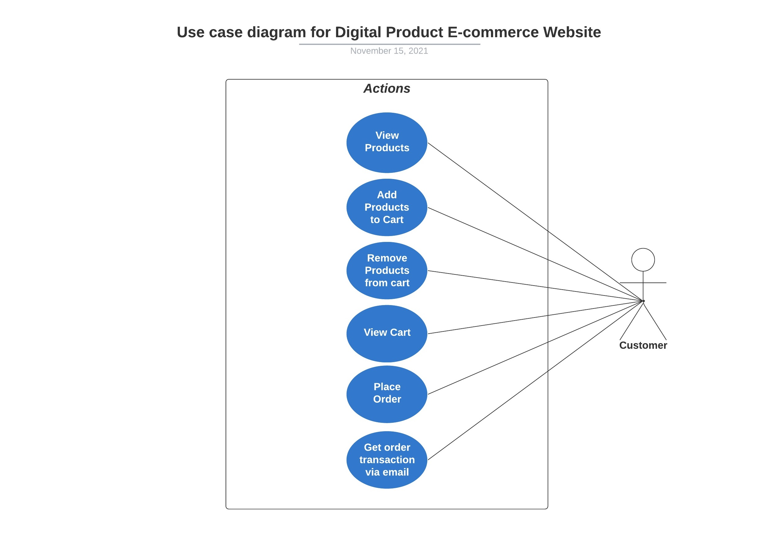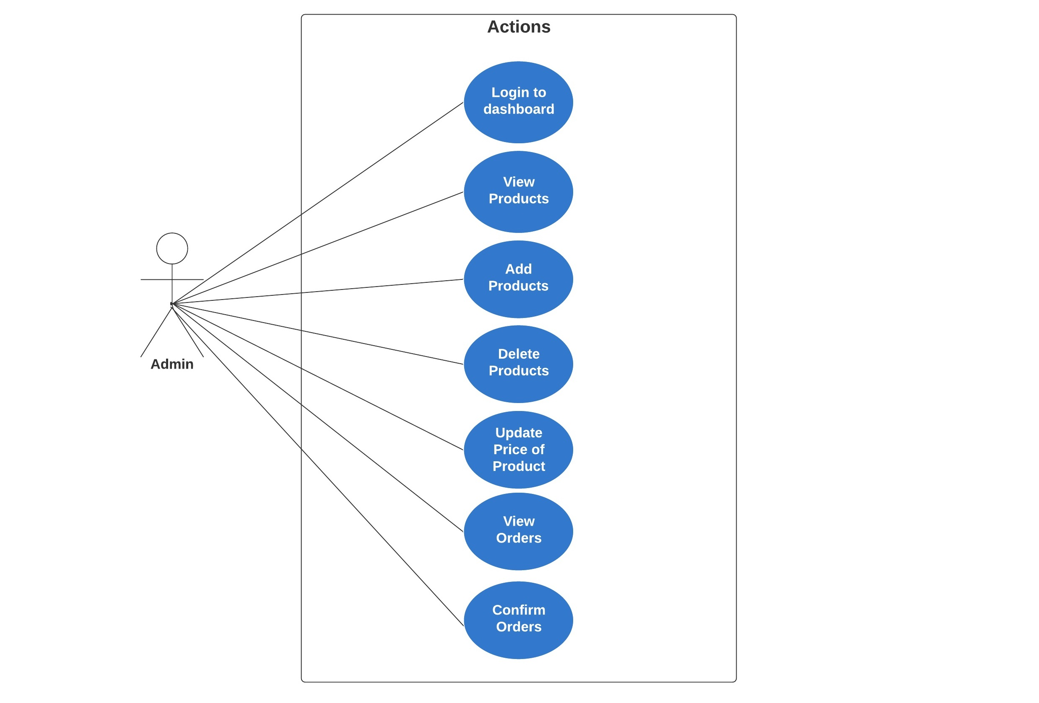

# Other Nonfunctional Requirements

* **User-friendly:** This is a user-friendly system where customers can use this very easily.
* **Appearance:** People can always access this system except when the server is down.
* **Privacy:** Any kind of customer information shall not disclose to anyone.
* **Maintenance:** A database is used to maintain all the data of the system.
* **Data Security:** Any kind of data in the database shall not lose or disappear.
* **Performance Efficiency:** The system is fast. Also, this system is efficient that it doesn’t get hang due to the heavy traffic of user